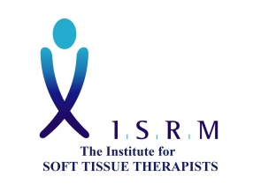
Application to join ISRM

Name
Email |  | Tel.

Qualifications and courses attended (only those relevant to Soft Tissue Therapy)
Title and Level (if applicable) | Year

Please give brief answers to the following

What types of conditions do you treat?

What assessment methods do you use?

What treatment methods and/or techniques do you use?

What rehabilitation methods do you use?

Why do you want to join ISRM?

Thank you for providing this information. Please send the completed form back to admin@theisrm.com. Also include a CV if you have one.

We will consider your application and get back to you shortly.

